Project title: NFL Draft and Combine

Group members: Simon Feinsilver, Patricia Berry, Luis Ruiz, Jared Graeve

Project Description/Outline

ETL Consultants are trying to create a database for NFL teams where they can view a players combine performance to their actual draft position. The idea is that teams would be able to use historical data on past players to determine the ideal draft position of future players. We plan on looking at 5 years worth of combine results and draft results in order to build our database.

Research Question to Answer

Where are players drafted based on:

* Combine results?
* School attended?
* Conference played in?

Using the database is their an accurate way to predict where a player is going to be drafted, based on this criteria, so that teams can properly position themselves to get the players they want?

Datasets to be used

Source:

<https://www.pro-football-reference.com/draft/2019-combine.htm#combine> (used to get combine results years 2016 to 2020)

<https://en.wikipedia.org/wiki/2020_NFL_Draft> (used to get the draft results years 2016 to 2020)

* On the pro-football-reference website we are interested in the results of all the exercises the players participated in (40yd dash, vertical jump, bench press, broad jump, 3 cone drill, shuttle drill) as well as their physical attributes (height and weight).

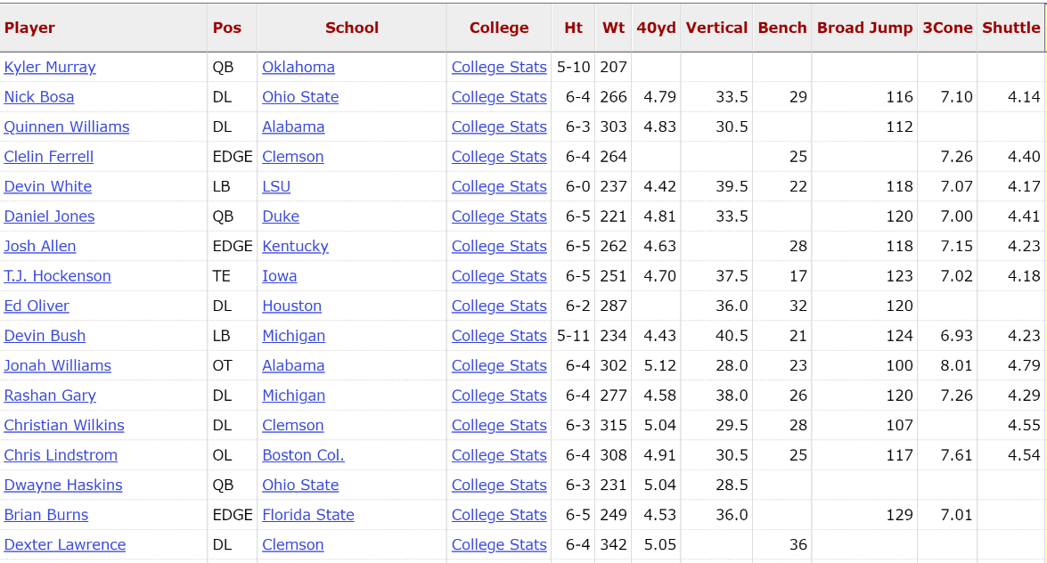

* On the Wikipedia page we are interested in the round, pick #, NFL Team, player name, position, college and conference.

